Kayla Stevens
MTH 4040
Graph Transformations Using Desmos
Directions:
Go to: www.desmos.com
Select “Start Graphing” on the top center

Definitions:
Quadratic: involving the second and no higher power of the unknown quantity or variable.
Translation: to change from one place, state, form or appearance to another.
Quadratic function: $a(x+{b)}^{2}+c$

Steps to transform quadratic functions:
Step 1:
Graph a standard parabola into the first items bar by typing $x^{2}$ using your keyboard or use the Desmos keyboard provided by selecting each term with your mouse.
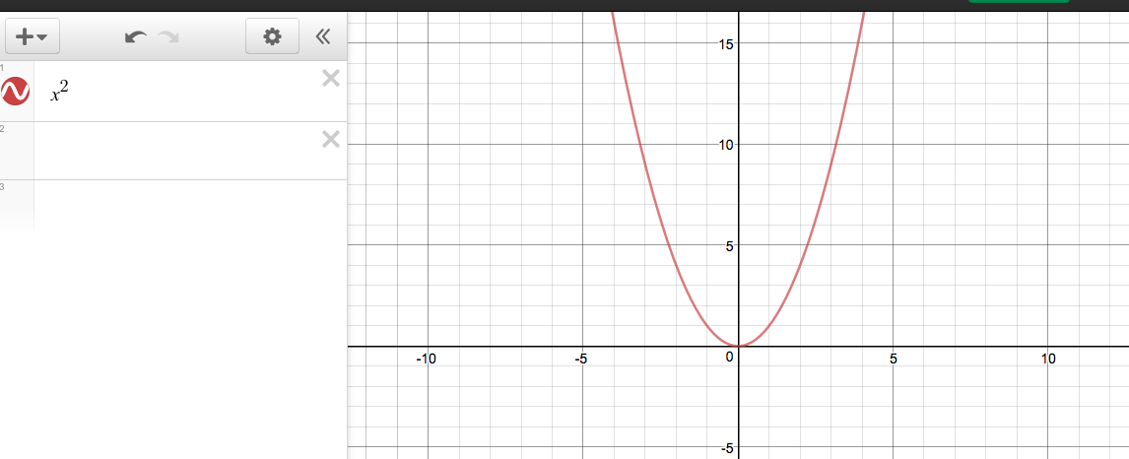

Step 2:
Type the quadratic function into the second items bar: $a(x+{b)}^{2}+c$ (exactly how it is shown). You can do this by using your keyboard or use the Desmos keyboard provided by selecting each term with your mouse.
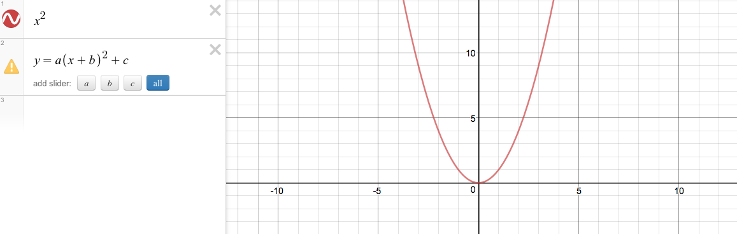

Step 3:
Underneath the quadratic function you just entered, there will be an option to:
Press all to display the graph and the sliders for each variable (a, b, and c).
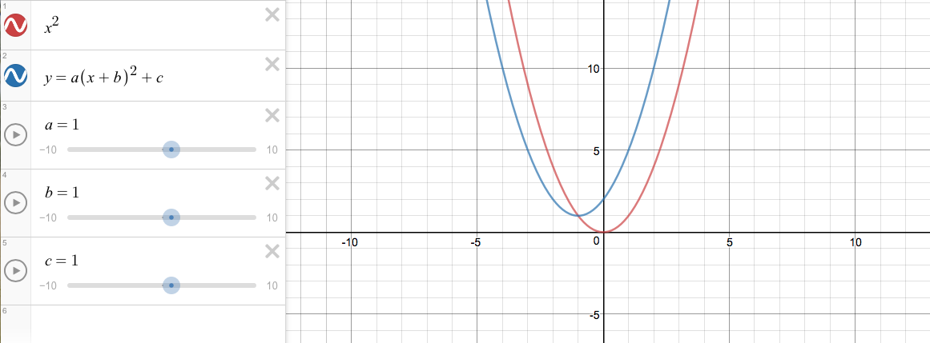

Step 4:
For the graph to intersect at the point (0,0) and for it to overlap our$x^{2}$ graph, change b = 1 to
b = 0 and c = 1 to c = 0. Do this by clicking directly next to 1 in the 4th items bar and then delete 1 and type 0 with your keyboard or use the keyboard provided on the Desmos screen by using your mouse to navigate through. Do the same for c. This will serve as our starting point to see how changing the values of a, b, and c will affect the graph.
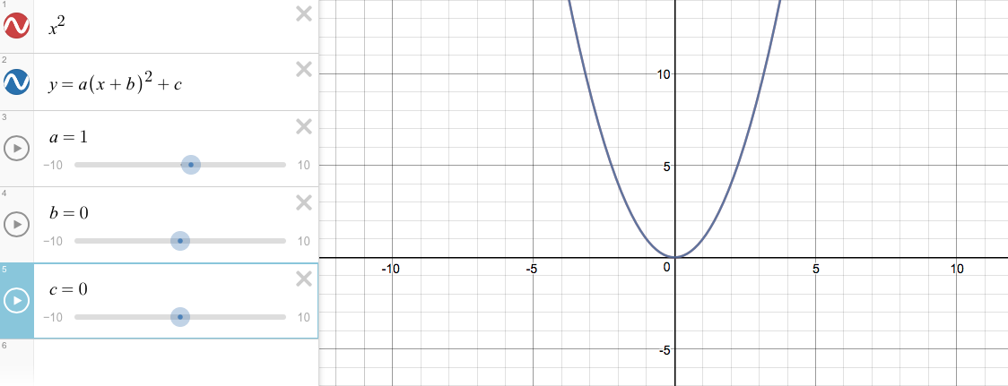

Step 5:
Let’s change the axes of our graph so it is easier to see the transformations that are occurring. To do this you will press: in the upper right hand corner. Change both the X-Axis and Y-

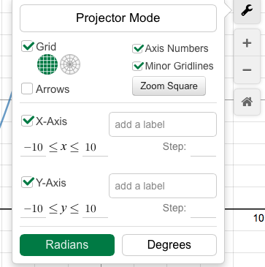
Axis to have a minimum of $-10$ and a maximum of 10.

Step 6: The Effects on Variable a
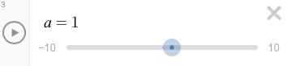
To see how the graph transforms when the variable ‘a’ changes move the a slider. To move the slider, click and hold your mouse on the blue circle and drag it to the right (positive) or to the left (negative).

- Let’s move the slider to $3$.

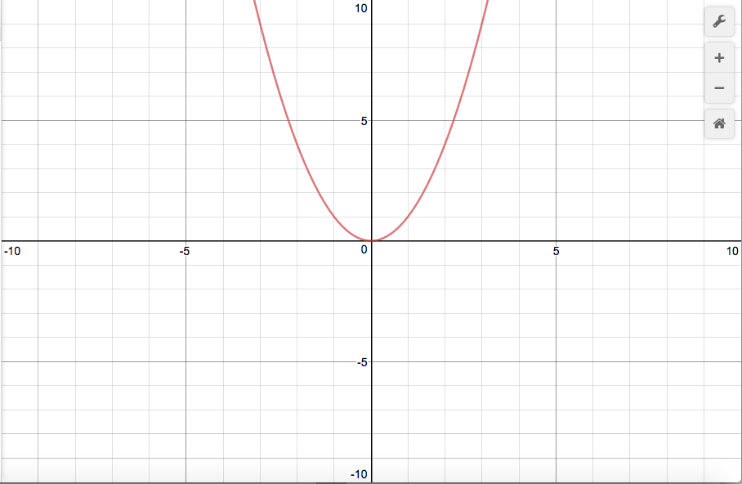

- Let’s move the slider to a number less than 1, but still positive, try 0.5.

- Now let’s try negative numbers. Move the slider to $-3$.

- Move the slider to a number less than $-3$, try $-6$.

What affect does variable a have on the graph?

Step 7: The Effects on Variable b
First, change variable ‘a’ back to, a = 1 (if you are unsure how to do so refer to step 4). Next, see how the graph transforms when ‘b’ changes by moving the b slider.
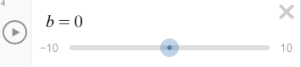

- Let’s move the slider to 3.

- Let’s move the slider to a number greater than $3$, try $6$.

- Now let’s try negative numbers. Move the slider to $-3$.

- Move the slider to a number less than $-3$, try $-6$.

What affect does variable b have on the graph?

Step 8: The Effects on Variable c
First, change variable ‘b’ back to b = 0 (if you are unsure how to do so refer to step 4). Next, see how the graph transforms when ‘c’ changes by moving the c slider.
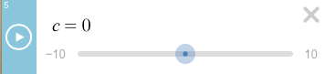

- Let’s move the slider to 3.

- Let’s move the slider to a number greater than $3$, try $6$.

- Now let’s try negative numbers. Move the slider to $-3$.

- Move the slider to a number less than $-3$, try $-6$.

What affect does variable c have on the graph?

In Conclusion
Answer the following multiple choice questions to conclude graphing transformations for quadratic functions.

1) When a is negative the graph…

- Shifts to the right
- Shifts down
- Shifts to the left
- Reflects over the x-axis

2) When a is greater than 1 or less than -1 the graph…

- Horizontally stretches
- Horizontally shrinks
- Vertically stretches
- Vertically shrinks

3) When a is between 0 and 1 or between 0 and -1 the graph…

- Horizontally stretches
- Horizontally shrinks
- Vertically stretches
- Vertically shrinks

4) When b is negative the graph...

- Shifts to the right
- Shifts down
- Shifts to the left
- Shifts up

5) When b is positive the graph...

- Shifts to the right
- Shifts down
- Shifts to the left
- Shifts up

6) When c is negative the graph…

- Shifts to the right
- Shifts down
- Shifts to the left
- Shifts up

7) When c is positive the graph…

- Shifts to the right
- Shifts down
- Shifts to the left
- Shifts up

Extra Problems to Try!

- Consider an exponential function ($y={ab}^{x}$). How will each variable effect the transformation of the graph?

- Consider a cubic function: $y={ax}^{3}+{bx}^{2}+cx+d$. How will each variable effect the transformation of the graph?

